FORT CHADBOURNE FOUNDATION
651 FORT CHADBOURNE ROAD
BRONTE, TX 76933
(325) 743-2555 -OFFICE
(325) 743-2354 –FAX
www.ftchadbourne.org
ftchadbourne@taylortel.com

Field Trip Form

Name of School_________________________________________________

City/Town _____________________________________________________

Teacher(s)______________________________________________________

_______________________________________________________________

Contact Number ________________________________________________

Email _________________________________________________________

Grade(s)___________________ ____Estimated time of arrival__________

Number of Students Attending ________Teachers ____________________

Release forms must be signed by a parent or guardian for each child attending

______ I am including the release forms with this form

______ I will bring release forms when we come

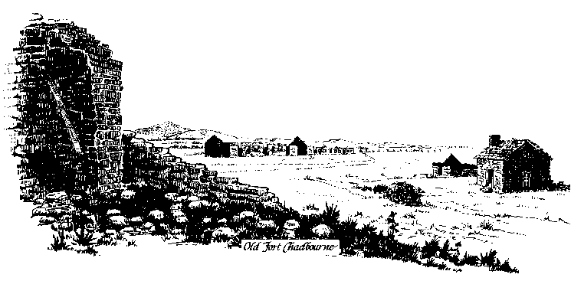

SCHOOL
GENERAL AND COMPLETE RELEASE AND DISCHARGE

As a guest of the CHADBOURNE RANCH, GARLAND AND LANA RICHARDS,
CHADBOURNE HUNTING, INC. AND THE FORT CHADBOURNE FOUNDATION, (hereinafter referred to as “Chadbourne”), I hereby acknowledge that my eligibility to participate in certain activities described below is expressly conditioned upon my representations in this Release. I hereby release and discharge Chadbourne, its stockholders, officers, managers, partners, affiliates, assignees, employees, owners and agents, and any and all persons liable or responsible in any way for the acts, omissions or negligence of such persons as well as all related or affiliated entities and individuals (all of whom are hereinafter referred to as the “Released Persons”) from any liability or responsibility, directly or indirectly related to certain activities which could be hazardous and dangerous to me, my property, other persons in my group, or the property of others, including, without limitation, hunting, target shooting, paneling firearms, hiking, riding in vehicles in rough terrain, transporting killed or harvested animals, dealing with wild animals, and all other indoor and outdoor activities. My release and discharge of the Released Persons covers and includes, without limitation, any claim, right or cause of action by reason of any injury (including death) or damage to me or anyone associated with or related to me or injury or damage to my property or the property of others irrespective of how such injury or damage may be caused. I understand and acknowledge that the activities that I may engage in are inherently hazardous and dangerous and could involve the use of firearms, wild animals, horses and other livestock in close proximity to me, others, my property and the property of others and that this hazard and danger presents a definite risk of harm. I acknowledge that I have actual knowledge of and appreciation for this hazard, danger and risk of harm. I further represent and agree that the Released Persons have adequately warned me of the hazards, dangers and risks of harm associated with my participation in these activities and that my status as a guest, invitee and participant in these activities is expressly conditioned upon and subject to my full acknowledgment and appreciation of both the risk of harm and the adequacy of this warning. I further understand that the Released Persons are relying upon my representations that I acknowledge the adequacy of the warning and appreciate the risk of harm. I understand that, during my participation in these activities, the negligence of other persons may cause serious injury or death to me or damage my property or the property of others even though these other persons are being reasonably supervised. I fully agree to the fully and solely responsible for any minor child for whom I am a parent, guardian, custodian or conservator.

I further agree that all film production units, photographers, and other reproducers of my image or likeness have the right to use and license to others the use of my likeness and voice in all manner and means, worldwide and in perpetuity, without limitations, fee or royalty, including but not limited to the use of such image, likeness or voice on film, movies, movie trailers, video, DVD, music videos and soundtracks, and all promotional and merchandising efforts associated therewith.

Name of student:_______________________________
(please print)
Parent or Guardian:_____________________________ Signature:________________________
(please print) (parent or guardian sign here)
School: __________________________________ Email: __________________________

Address: __________________________________
(Students)

__________________________________

Telephone: __________________________________

Date(s): May 1, 2015 (Friday)

